**Prefix Sum QUESTIONS**

Table of Contents

**Theory** 1

What is Prefix sum? 2

Examples of usage of prefix sum 2

1. Efficient Range Sum Queries: 2

2. Counting occurrence in range: 2

3. Equal subarrays: 3

https://leetcode.com/problems/number-of-ways-to-split-array/ 3

**Important questions** 5

1. Find the pivot integer 5

Binary Search Tree Implementation: 6

Traversals: 7

Breadth First : 9

LEVEL 1: **Amateur** 10

1. ererfer 10

LEVEL 2: **Pro** 11

1. Unique length 3 palindromic subsequences 11

2. Shifting Letters II 11

LEVEL 3: **Legend** 13

**SOLUTIONS:** 14

**LEVEL 1:** 14

**LEVEL 2:** 15

# **Theory**

## What is Prefix sum?

A prefix sum is an array derived from an input array such that the value at each position in the prefix sum array is the sum of all elements up to that position in the original array. Mathematically, if the input array is A and the prefix sum array is P, then *P*[*i*]=∑*j*=0*i*​*A*[*j*].

Usually used for range queries.

Eg:-

If A = [ 2, 3, 5, 9]

Prefix Sum = P

P[0] = A[0] , P[1]=A[0]+A[1] ,P[2] = A[0]+A[1]+A[2] ,P[3] = A[0]+A[1]+A[2]+A[3]

So P = [2, 2+3, 2+3+5 , 2+3+5+9] = [ 2, 5, 10, 19]

It is also equivalent to , P[i] = P[i-1] + A[i]

def fillPrefixSum(arr, n, prefixSum):

    prefixSum[0] = arr[0]

*# Adding present element with previous element*

    for i in range(1, n):

        prefixSum[i] = prefixSum[i - 1] + arr[i]

*# Driver code*

if __name__ == '__main__':

  arr = [10, 4, 16, 20]

  n = len(arr)

  prefixSum = [0 for i in range(n + 1)]

  fillPrefixSum(arr, n, prefixSum)

  print(prefixSum)

*#output: [10,14,30,50,0] ( here we have 0 at end, can have it at start too)*

## Examples of usage of prefix sum

### Efficient Range Sum Queries:

Prefix sums are often used to quickly calculate the sum of elements within a given range in an array. Example: Given an array arr, prefix_sum[i] can be used to calculate the sum of elements from index 0 to i efficiently.

def range_sum_query(prefix_sum, left, right):

    return prefix_sum[right] - prefix_sum[left - 1] if left > 0 else prefix_sum[right]

*# Example usage:*

arr = [1, 2, 3, 4, 5]

prefix_sum = [0] + [sum(arr[:i+1]) for i in range(len(arr))]

*#not an effiecient way to find prefix_sum*

print(range_sum_query(prefix_sum, 1, 3))  *# Output: Sum of elements from index 1 to 3*

### Counting occurrence in range:

Prefix sums can be used to efficiently count the occurrences of a value in a given range.

Example: Given an array arr, prefix_sum[i] represents the count of a specific value up to index i.

Approach: here prefix sum will save the count of occurrence of the value

*#get occurences of num in given range[l,r] inclusive(for l,r 1-based index)*

def get_occurrences(arr,val,left,right):

    n = len(arr)

    prefix_sum = [0]*(n+1)   *#will keep 0 in start*

    for i in range(1,n+1):

        if arr[i-1]==val:

            prefix_sum[i] = prefix_sum[i-1] + 1

        else:

            prefix_sum[i] = prefix_sum[i-1]

    return prefix_sum[right]-(prefix_sum[left - 1] if left > 0 else 0)

*# Example usage:*

arr = [1, 2, 2, 3, 4, 2, 5]

*# Output: Count of occurrences of 2 in the range [1, 5] ->[1,2,2,3,4] =2*

print(get_occurrences(arr, 2, 1, 6))

These examples showcase how prefix sums can be used to efficiently solve various problems related to range queries, subarray sums, and counting occurrences. They help reduce time complexity by precalculating cumulative sums.

### Equal subarrays:

Check if there are two subarrays with same sum.

Example: Given an array arr, prefix_sum[i] represents the count of a specific value up to index i.

Approach: here prefix

# https://leetcode.com/problems/number-of-ways-to-split-array/

class Solution:

    def waysToSplitArray(*self*, *nums*: List[int]) -> int:

        n = len(*nums*)

        pre = [0]*n

        pre_sum=0

*for* i *in* range(n):

            pre_sum += *nums*[i]

            pre[i] = pre_sum

        pairs=0

        last = pre[-1]

*for* i *in* range(n-1):   *#only till n-1 to have atleast one value in right subarray*

*if* pre[i] >= last-pre[i]:

                pairs+=1

*return* pairs

Difference Array concept:

[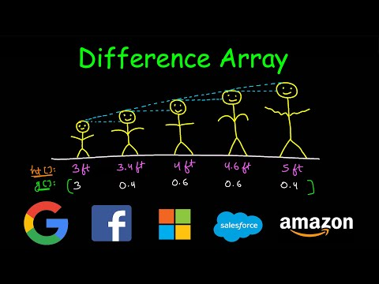](https://www.youtube.com/watch?v=R-PBfqsRGP0)

# **Important questions**

### Find the pivot integer

Given a positive integer n, find the pivot integer x such that: The sum of all elements between 1 and x inclusively equals the sum of all elements between x and n inclusively.(easy)

Link: <https://leetcode.com/problems/find-the-pivot-integer/description/>

Approach:-

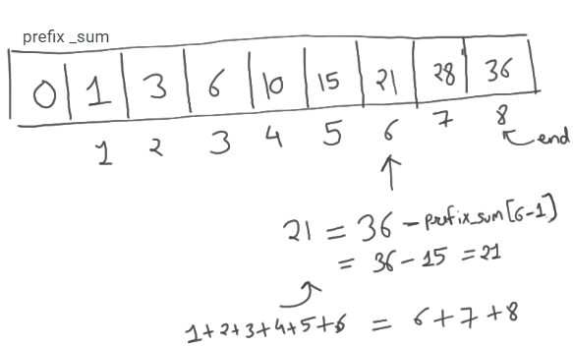

class Solution:

    def pivotInteger(self, n: int) -> int:

        prefix_sum = [0]*(n+1)

        for i in range(1,n+1):

            prefix_sum[i] = prefix_sum[i-1] + i

        ans = -1

        end = prefix_sum[-1]

        for i in range(1,n+1):

            if(prefix_sum[i] == (end-prefix_sum[i-1])):

                ans = i

                break

        return ans

Approach 2

By observation, if total sum till n = a perfect square, then pivot integer is square root of sum

n=4

x = (n*(n+1)/2)**0.5

print(x,x%1)            *#3.1622777..., 0.162277..*

print(-1 if x%1 else int(x))   *#x%1 is way to check if number is whole number*

n=8

x = (n*(n+1)/2)**0.5

print(x,x%1)          *#6.0 , 0.0*

print(-1 if x%1 else int(x))

[](https://www.youtube.com/watch?v=fFVZt-6sgyo)

# LEVEL 1: **Amateur**

### ererfer

Link: <https://leetcode.com/problems/same-tree/description/>

# LEVEL 2: **Pro**

<https://www.youtube.com/watch?v=80Zug6D1_r4>

### Unique length 3 palindromic subsequences

Link: <https://leetcode.com/problems/unique-length-3-palindromic-subsequences/description>

https://www.youtube.com/watch?v=0rTkpQC8ytY

class Solution:

    def countPalindromicSubsequence(*self*, *s*: str) -> int:

        d = {}

        n = len(*s*)

*#to get first and last occurrences*

*for* i *in* range(n):

*if* *s*[i] in d:

                d[*s*[i]][1] = i

*else*:

                d[*s*[i]] = [i,i]

        subs = 0

*for* c *in* d.keys():

            f,l = d[c][0],d[c][1]   *#first and last occurrences of character*

            subs += len(set(*s*[f+1:l]))   *#f+1 else it will include c in that set*

*return* subs

### Shifting Letters II

Link: <https://leetcode.com/problems/shifting-letters-ii/description/>

Remainder theorem:

To get remainder of –a%b = b – (a%b)

* -7%5 = 5 – (7%5) = 5-2 = 3

[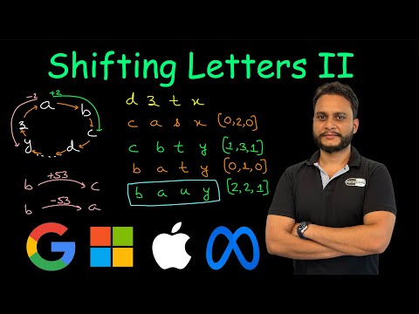](https://www.youtube.com/watch?v=jJdUJoiqdmQ)

*#For each query [l,r,t] - A is net shift after all shifts done*

*# a) if t==1 (right shift) , then A[l] += 1 and A[r+1] -= 1 if(r+1) < n.*

*# b) if t==0 (left shift) , then A[l] -= 1 and A[r+1] += 1 if(r+1) < n.*

class Solution:

    def shiftingLetters(*self*, *s*: str, *shifts*: List[List[int]]) -> str:

        alphabet = 'abcdefghijklmnopqrstuvwxyz'  *# to get letters in loop*

        d = {}       *#to get index of char faster*

*for* i *in* range(26):

            d[alphabet[i]] =i

        arr = list(*s*)

        n = len(*s*)

        A = [0] * n

*#logic for difference array*

*for* l, r, t *in* *shifts*:

*if* t == 1:

                A[l] += 1

*if* r + 1 < n:

                    A[r + 1] -= 1

*else*:

                A[l] -= 1

*if* r + 1 < n:

                    A[r + 1] += 1

*for* i *in* range(1, n):

            A[i] += A[i - 1]

*#Note (-1%26 = 25)*

*#logic to update our arr*

*for* i *in* range(n):

            c = A[i]

            index = (d[arr[i]] + c) % 26  *#Imp*

            arr[i]= alphabet[index]

*return* ''.join(arr)

https://leetcode.com/problems/minimum-number-of-operations-to-move-all-balls-to-each-box

Solution: https://leetcode.com/problems/minimum-number-of-operations-to-move-all-balls-to-each-box/submissions/1499647872/?envType=daily-question&envId=2025-01-06

# LEVEL 3: **Legend**

# **SOLUTIONS:**

## **LEVEL 1:**

## **LEVEL 2:**